Unit 1C1 Park Business Centre
Hastingwood Ind Park
Wood Lane, Erdington B24 9QR
Tel: 07751 451 427 / 07941 300 949
Email:office@wmspeechtherapy.co.uk
www.wmspeechtherapy.co.uk
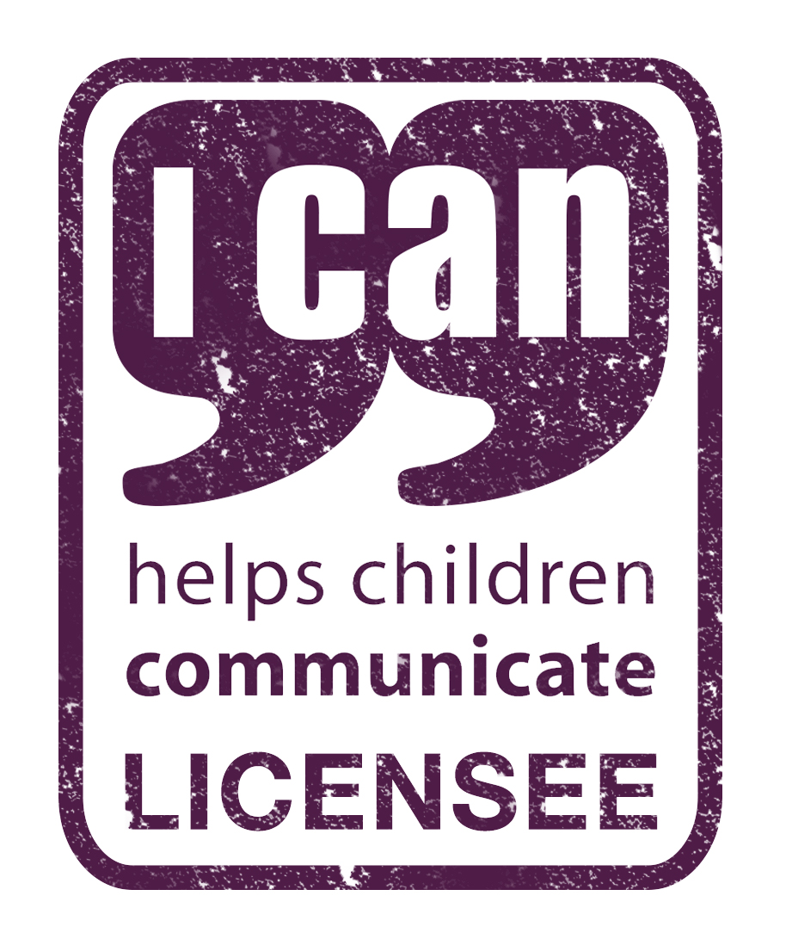
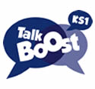
ICAN ONLINETRAINING BOOKING REQUEST

To book, please complete using BLOCK CAPITALS and return with purchase order to the above address. Your booking will be confirmed via email on receipt of completed booking form and purchase order. Please do not use this form for Primary Talk inset bookings
INVOICES MUST BE SETTLED PRIOR TO THE COURSE DATE.

BOOKING DETAILS
Course Name: | TALK BOOST KS1
Course Date: | 2ND December 9.30am-12.30 and  10th December 2020 1 – 3.30pm
Course Fee per/pair | £ 200 | ICAN Training materials per/pair | £ 500 plus £10 delivery charge

DELEGATE DETAILS
Name of Teacher: |  | Name of TA:
School:
Address:
Email:
Telephone:
Employer Authority:
Email address for invoice:

This booking form is one of a collection to be included on one invoice

Purchase order attached with this booking form – Number: Amount: £

Signature of delegate: Date:

Deadline for applications 20/11/2020

